THEORY QUESTIONS
1.
Study Figure 1 carefully and use it to answer questions (a) to (e)
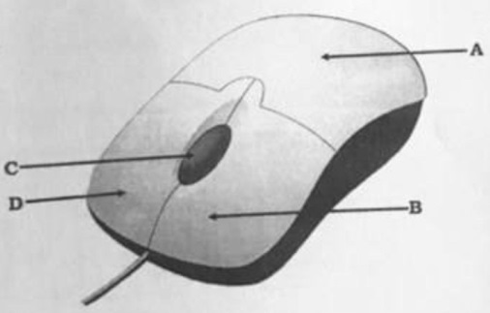
Figure 1
a)

Write down the name of the device displayed in Figure 1.
b)

Write down the name of the parts of Figure 1 labelled A, B, C and D.
c)

State three uses of the device identified in Figure 1.
d)

State three devices that function as the one shown in Figure 1.
e)

What is the name of the flat material on which the device shown in Figure 1 is mostly placed?

2.
a)

What is a search engine?
b)

List three examples of a search engine.
c)

What does the following domain of a website address represent.
i)

.edu
ii)

.biz
iii)

.int

3.
a)

State three reasons that will compel a user to restart a computer.
b)

State three ways by which an application can be launched using its shortcut icon on the desktop.

4.
Use the image shown in Figure 2 to answer question (a) and (b).
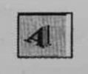
Figure 2
a)

Write the name of the image shown in Figure 2.
b)

State the function of the image shown in Figure 2.
c)

Which tool on the drawing toolbar is used to colour a drawn object.
d)

State three uses of the drawing toolbar.

5.
a)

Write three features that are common to both Microsoft Word and Microsoft Excel.
b)

List three data types of a Spreadsheet application.

